1.Communication Specification
Baud rate 115200 bps or 9600bps
Transmission code ASC II
Data length 8 bit
Stop bit length 1 bit
Parity check None
- Communication Data Format (Command)

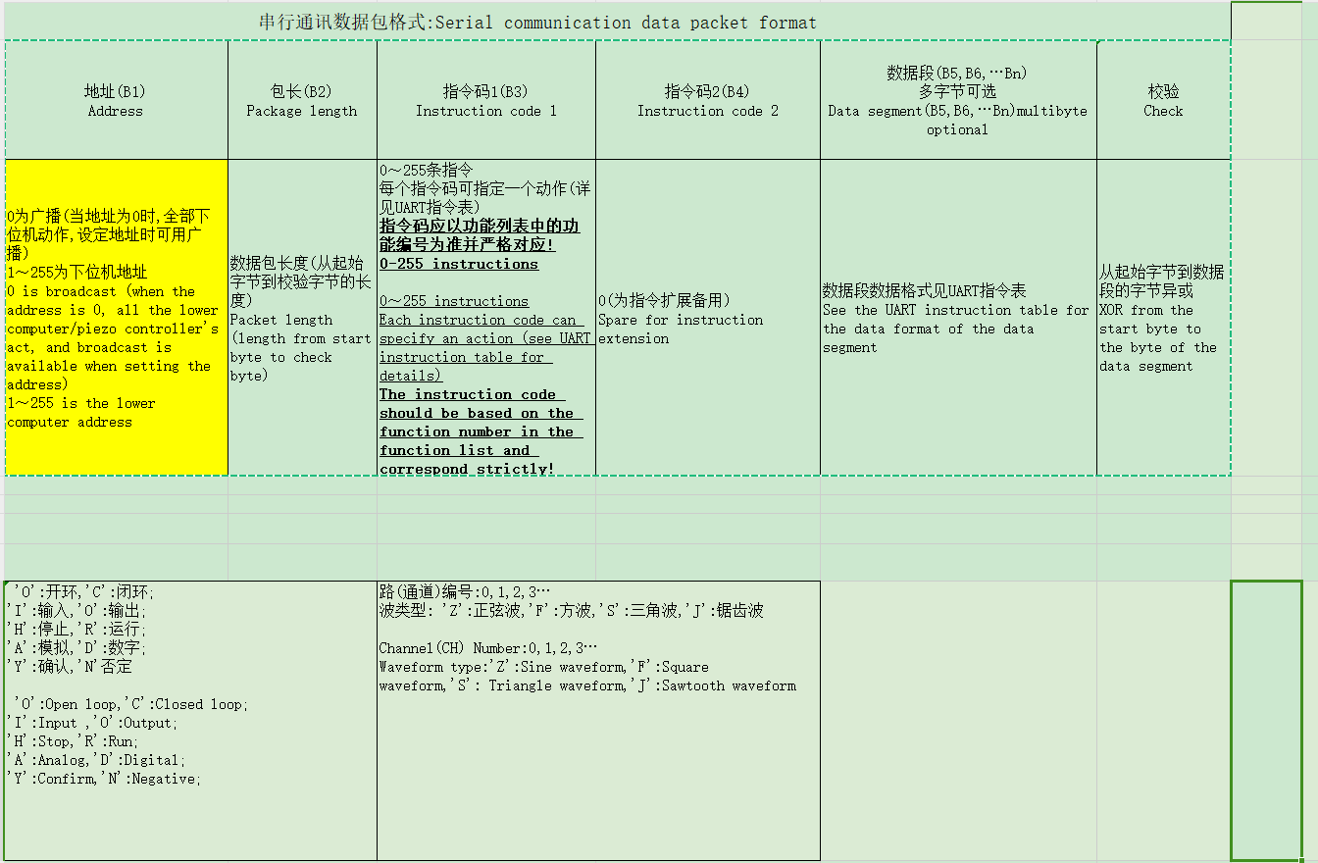
Example send 10.001 volt：
Transmission code ASC II:0xaa 0x01 0x0b 0x00 0x00 0x00 0x00 0x0a 0x00 0x0a 0xa0
Unsigned char sendDataArr[11];
sendDataArr[0] = 0xaa;
sendDataArr[1] = 0x01;//Address default 1
sendDataArr[2] = 0x0b;//package length
sendDataArr[3] = 0x00;//B3 instruction code 1
sendDataArr[4] = 0x00;//B4 instruction code2
sendDataArr[5] = 0x00;//Channle Num 0 =ch1;1=ch2;2=ch3;
sendDataArr[6] = 0x00;
sendDataArr[7] = 0x0a;
sendDataArr[8] = 0x00;
sendDataArr[9] = 0x0a;//[6][7][8][9] 10.001; by
sendDataArr[10] = 0xa0;// Check bit: Data sent starting at 0xaa is XOR checked against 0x00, and //the obtained check data is checked with the second data until it is checked with the last data, //and the obtained check data is placed in the last one;
See it :10.001 to fourchar:0x00 0x0a 0x00 0xaa
unsigned char* CXE_DoITDlg::DataAnla(double f,unsigned char kk[4])///浮点数转化为 4个char Convert floating point numbers to 4 uchar
{
// if(chenfeng==1)sprintf(buf,"%d",addr_save);
if(f<0)//f中的内容为负数 The contents of F are negative
{
f*=(-1);//将F中的内容转换为正数 Convert the contents of F to positive
int a=int(f);
kk[0]=a/256+0x80;//将F中的内容转换为负数 Convert the contents of F to negative
kk[1]=a%256;
a=int((f-a)*10000);
kk[2]=a/256;
kk[3]=a%256;
}
else
{
int a=int(f);
kk[0]=a/256;
kk[1]=a%256;
a=int((f-a+0.000001)*10000);
kk[2]=a/256;
kk[3]=a%256;
}
return kk;
}
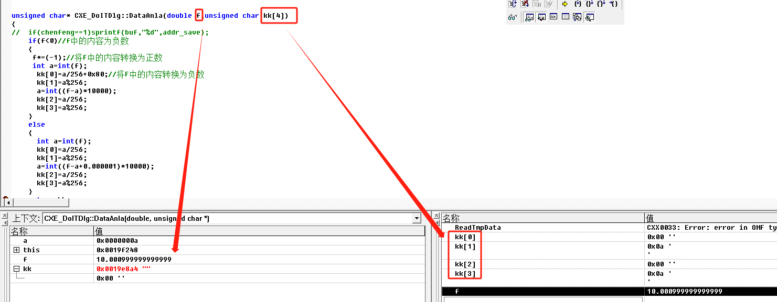
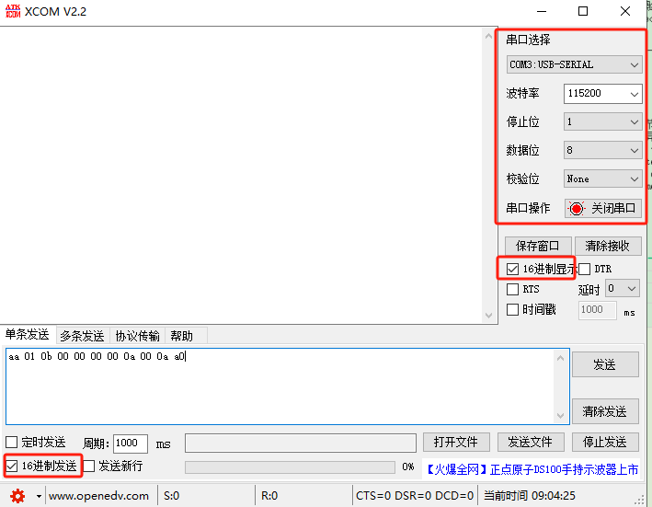

Read volt :
Read volt :
ransmission code ASC II:0xaa 0x01 0x07 0x05 0x00 0x00 0x00 0xa9
Unsigned char sendDataArr[7];
sendDataArr[0] = 0xaa;//beginData
sendDataArr[1] = 0x01;//Address default 1
sendDataArr[2] = 0x07;//package length
sendDataArr[3] = 0x05;//B3 instruction code 1
sendDataArr[4] = 0x00;//B4 instruction code2
sendDataArr[5] = 0x00;//Channle Num 0 =ch1;1=ch2;2=ch3;
sendDataArr[6] = 0xa9;;// Check bit: Data sent starting at 0xaa is XOR checked against 0x00, and //the obtained check data is checked with the second data until it is checked with the last data, //and the obtained check data is placed in the last one;

recArr: 0xaa 0x01 0b 05 00 00 00 33 22 47 f3
recDataArr[0] = 0xaa;//beginData
recDataArr[1] = 0x01;//Address default 1
recDataArr[2] = 0x0b;//package length
recDataArr[3] = 0x05;//B3 instruction code 1
recDataArr[4] = 0x00;//B4 instruction code 2
recDataArr[5] = 0x00;//Channle Num 0 =ch1;1=ch2;2=ch3;
recDataArr[6] = 0x00;
recDataArr[7] = 0x03;
recDataArr[8] = 0x22;
recDataArr[9] = 0x47;//[6][7][8][9] The received data is converted to a floating point number
recDataArr[10] = 0xf3;// Check bit: Data sent starting at 0xaa is XOR checked against 0x00, and //the obtained check data is checked with the second data until it is checked with the last data, //and the obtained check data is placed in the last one;

The received data is converted to a floating point number: 0x00 0x3 0x22 0x47=>38975
unsigned char* CXE_DoITDlg::DataAnla(double f,unsigned char kk[4])///浮点数转化为 4个char Convert floating point numbers to 4 uchar
{
// if(chenfeng==1)sprintf(buf,"%d",addr_save);
if(f<0)//f中的内容为负数 The contents of F are negative
{
f*=(-1);//将F中的内容转换为正数 Convert the contents of F to positive
int a=int(f);
kk[0]=a/256+0x80;//将F中的内容转换为负数 Convert the contents of F to negative
kk[1]=a%256;
a=int((f-a)*10000);
kk[2]=a/256;
kk[3]=a%256;
}
else
{
int a=int(f);
kk[0]=a/256;
kk[1]=a%256;
a=int((f-a+0.000001)*10000);
kk[2]=a/256;
kk[3]=a%256;
}
return kk;
}

